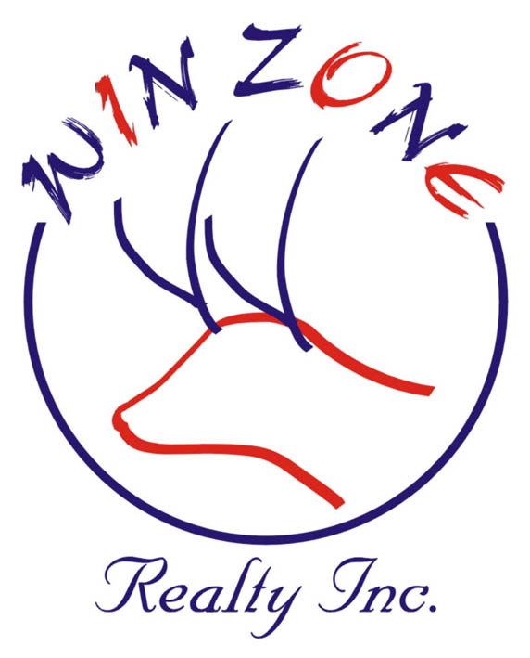 WINZONE REALTY INC.
Office: 81-15 Queens Blvd #2A Elmhurst NY 11373 Phone 718-899-7000 Fax 718-899-2000
Branch: 7405 18 Ave Brooklyn NY 11204 Phone 718-676-6611 Fax 718-676-6622
Facsimile Transmittal
To: _____________________________________ Fax: ___________________________
From: ___________________________________ Date: __________________________
Re: _____________________________________________________________________
CC: _____________________________________________________________________
Urgent ___ For Review ___ Please Comment ___ Please Reply ___ Please Recycle___

______________________________________________________________________________

______________________________________________________________________________

______________________________________________________________________________

______________________________________________________________________________

______________________________________________________________________________

______________________________________________________________________________

Number of pages including cover sheet: ___________
If all pages are not received, please contact us immediately. Thank you.

